 | Autumn 1 | Autumn 2 | Spring 1 | Spring 2 | Summer 1 | Summer 2
Reception | 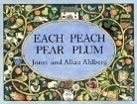  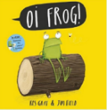  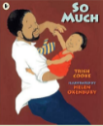  So Much Oi Frog! Each Peach Pear Plum. | 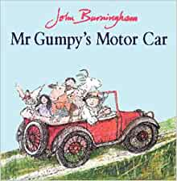  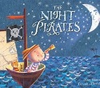  The Night Pirates Mr Gumpy’s Motor Car Where the Wild Things are  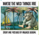 | 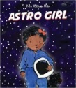  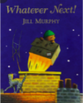  Look Up! Astro Girl Whatever Next! | A Tiny Seed  The Extraordinary Gardener  Jack and the Beanstalk    From Seed to plant  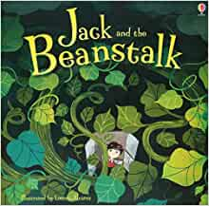   | The Queen’s Hat  The Princess and the Pea  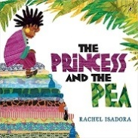  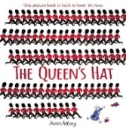 | Little Red  Anansi the Spider    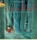
Year 1 | Cave Baby Leo and the Octopus  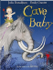  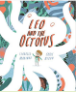 | I want my hat back Billy and the Beast  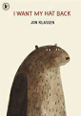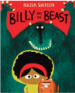 | The Comet The Odd Egg  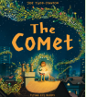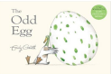 | Stanley’s stick  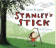 | Lost and Found Yeti and Bird  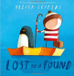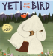 | Iggy Peck, Architect Julian is a Mermaid  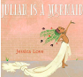
 | Narrative retellings Labels and captions Informal letters  Fact file This is me posters, letters of advice, factual descriptions, logbooks, scripts | Story sequels Questions, speech bubbles, letters, lists s Own version ‘defeat a monster’ narratives  Wanted posters, summaries, emails, character descriptions, recipes | Own version narrative Posters, letters of advice, poem, description, writing in role, recipes  Egg-spotter’s guides (nonfiction reports) Thought and speech bubbles, diaries, letter, certificate | Own version narratives Retellings, descriptions | Own version ‘losing/finding’ narratives Character descriptions, retellings, advice, instructions, non-chronological reports  Own version narratives about unlikely friendships List of rules, letters, postcards, character descriptions | Fact files, Labels, character, comparisons, character, descriptions, building descriptions, posters  Three-verse poems, Instructions, writing in role, advertisements
Year 2 | Goldilocks and the Three Bears Wolves  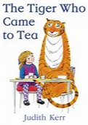 | The Journey Home We Are Water Protectors  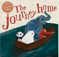 | The Bear Under the Stairs The Minpins  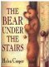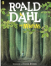 | The Owl and the Pussycat  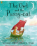 | Tadpole’s Promise Ocean Meets Sky  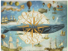 | Rosie Revere, Engineer Last Stop on Market Street  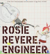
 | Sequel Stories Wanted posters, letters, retellings from another point of view, lists of rules, character descriptions  Non-chronological leaflets Captions, informaiton writing, character descriptions and comparisons | Persuasive letters Posters, lists, postcards, wanted posters, information reports, short stories | Information texts Letters, retellings, own version narratives  Own version adventure narratives Danger posters, setting descriptions, character descriptions, information reports, postcards | Rhyming poems Letters, interviews, lists, instructions | Own version narratives Simple explanations, speech and thought bubbles, setting descriptions, extended explanations  Own version fantasy world narratives Setting & character descriptions, labels, diaries, postcards, captain’s logs, instructions, dialogue | Explanation text, Short explanations, adverts, advice letters, characterdescription (school report), invention descriptions  Own version narrative, Poetry, simple character descriptions, interview questions, adverts, advice slips, letters
Year 3 | Leon and the Place Between The First Drawing  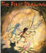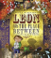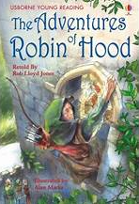 | The BFG The Tear Thief  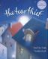 | The Pied Piper of Hamlin Escape from Pompeii  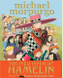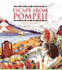 | Small in the city  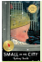 | Thames and Tide club Flotsam  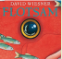 | Jim, A Cautionary Tale The Day I Swapped my Dad for Two Goldfish  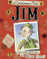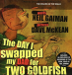
 | Own version fantasy narratives Persuasive posters, setting descriptions, thought bubbles/diaries, dialogue  Own historical narrative Character descriptions, diaries, recounts | Own version fantasy narratives Recount (diary entry), character descriptions, wanted posters, new chapters, instructions  Newspaper articles Shared poems, diary entries, persuasive posters, letters of explanation, discussions | Own version myths/legends Writing in role, information reports, adverts, formal letters  Newspaper reports Setting descriptions, diaries, letters, thought bubbles | Extended narratives from alternative perspective Setting description, poem, diary entry, dialogue, letter of advice, lost poster | Sequels (mystery narratives) Postcards, setting descriptions, non- chronological reports, message in a bottle letters | Narrative poems, Warning posters, warning announcements, alternative endings, performance poetry, letters of apology  Own version narratives, Thought bubbles, missing scenes, diaries
Year 4 | Tar Beach The Mermaid of Zennor  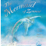  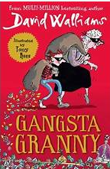 | FarTHER Cinnamon  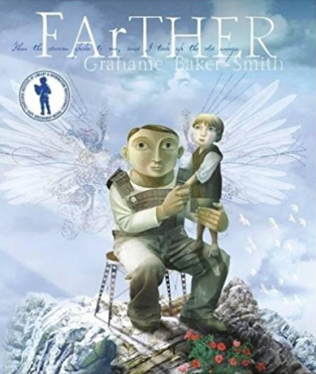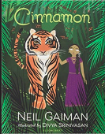 | Winter’s Child The Selfish Giant  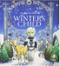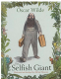 | The Lion and the Unicorn  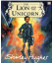 | Odd and the Frost Giants Shackleton’s Journey  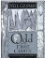 | The Lion, the Witch and the Wardrobe Jabberwocky  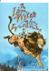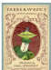
 | Narrative retelling as a play script Poetry, setting descriptions, formal letters, dialogue (as a script)  Own version legends  information booklets, retelling from a different perspective, letters, tourist guides | Retellings, recounts (postcards), setting descriptions, diary entries, instructions, Sequel story Diary entries, informal letters, dialogue, adverts, limericks and other poetry forms , own version fable | Fantasy story sequels Descriptive poems, postcards, dialogue, setting descriptions as letters, retellings  dialogue, setting descriptions as letters, retellings Own version narratives Letters, first person recounts, diaries, letters, posters, reports | Letters, diary entries, character and setting descriptions, non-chronological reports | Retellings - alternative perspective Narrative recounts, character and setting descriptions, letters, short explanations  Newspaper reports Packing lists (justifications), letters (formal and informal), interviews, diaries | Own version narratives (set in other worlds) Poems, eyewitness reports, imaginary conversations, writing in role  Nonsense poems, Performance poetry, explanatory descriptions
Year 5 | The Man Who Walked Between the Towers Robot Girl  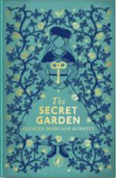   | The Tempest Percy Jackson  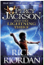 | The Island The Lizzie and Belle Mysteries  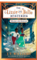 | The Sleeper and the Spindle  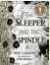 | Beowulf The Strange Case of Origami Yoda  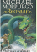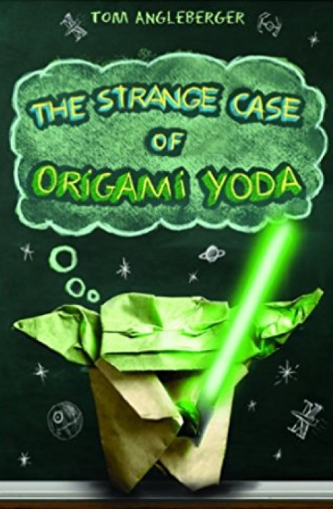 | High Rise Mystery Curiosity  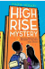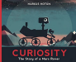
 | Biographies/Autobiographies  Information writing, letters of advice, interviews, news report, persuasive speeches  Science fiction narratives  Discussions, debates, dialogue, character comparisons, reviews | Playscripts Setting descriptions, character descriptions, diaries, dialogue  Mythical narratives Odes, soliloquies, setting descriptions, additional chapters, reports | Sequels Welcome guides, descriptions, letters of advice, diary entries in role, imagined conversations  Sequels Welcome guides, descriptions, letters of advice, diary entries in role, imagined conversations | Fairytale reworkings Warning posters, diaries, dialogue, estate agent’s descriptions, character descriptions, missing narratives | Own version legends/missing chapters Letters of advice, diaries, dialogue, character and setting descriptions, action scenes, obituaries  Discussion text, Instructions, persuasion, recount (diary entry | Extended stories, Character & setting descriptions, police & newspaper, report, dialogue, persuasive letters  Expanded explanations, NASA Proposals, information  labels, short explanations, NASA logs, news reports
Year 6 | The Arrival  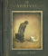 | Windrush Child  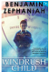 | The Explorers  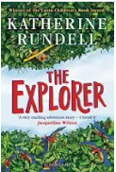 | Grimm Tales for Old and Young  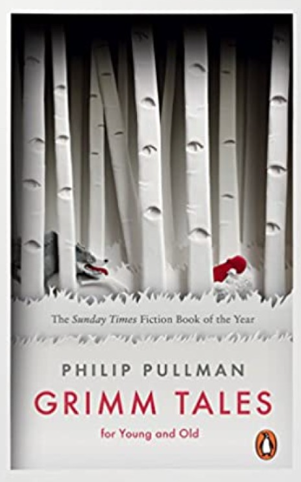 | Inspirational writing prompts to support achievement. | Some Places More Than Others  
 | Extended own version narrative Letters, lists of rules, character descriptions, diaries, short playscripts, short reports, guides | Persuasive pitch to the local council Thought bubble, informal letter, poem, diary entry, advice, informal letter | Newspaper report, Character description / profile, diary entry, report writing, formal letter writing, balanced argument, persuasive writing | Own version traditional tales Retellings, character studies, monologues | Teacher assessed to support excellence | The Suitcase Project, Transition project to represent children: maps, recipes, poems, photos and biography

