Example Design
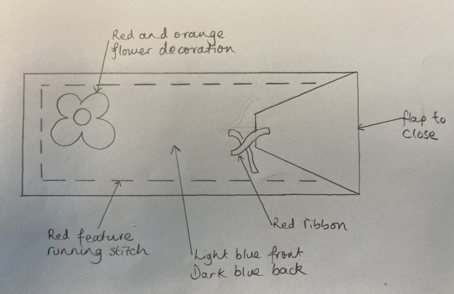
Textiles
Pencil Cases

Year 2 Firecrests
DT
Summer 2

This half term, we will be learning about the Industrial Revolution.

Key Vocabulary | Definition
appearance | What the finished product will look like.
design | Purpose or planning that happens to prepare to create a product.
fabric | Cloth or other material produced by weaving or knitting fibres.
fastening | To fix something securely to something else. Fastening can be permanent or temporary depending on whether the design requires the object to be able to be opened.
feature stitch | A sewing stitch that is deliberately coloured or patterned so that it stands out against the background.
function | What the object needs to do/ be used for.
materials | The things needed to create the object.
needle | A very fine slender piece of polished metal with a point at one end and a hole or eye for thread at the other, used in sewing.
properties | An attribute, ability or characteristic of something. E.g. waterproof, flexible etc.
running stitch | A straight stitch used to join two or more pieces of fabric. 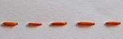
seam | A line where two pieces of fabric are sewn together in a garment or other article.
sew | To join, fasten, or repair (something) by making stitches with a needle and thread or a sewing machine.
stitch | A loop of thread or yarn resulting from a single pass or movement of the needle in sewing.
suitable | Right or appropriate for a particular person, purpose, or situation.
thread | A long, thin strand of cotton, nylon, or other fibres used in sewing or weaving.
user | A person who uses an object.

Instructions
Pin the template to the fabric. Attach the fastening.
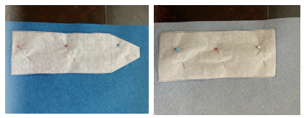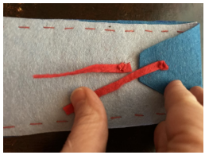
Cut out the fabric. Glue the decoration to the front.
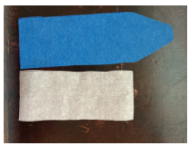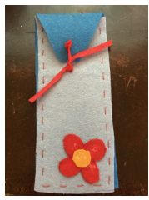
Use a running stitch to join the
front and the back. Try it out.


