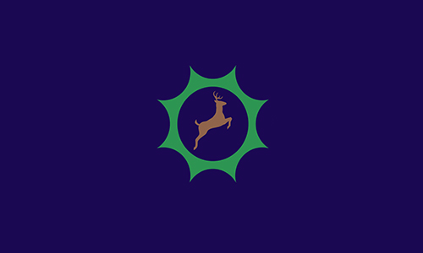
Year 2 Firecrests
History
Summer 2


Mahatma Gandhi
Mahatma Gandhi was born in 1869 in India. At the time of his birth India was part of the British Empire. Gandhi believed that India should have the independence to rule itself. Gandhi led peaceful protests which eventually led to India to being an independent country.

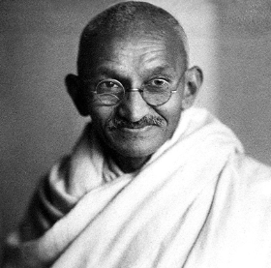

Catherine Anne

Powerful Voices

This half term, we will be learning about the Industrial Revolution.


Key Vocab | Definition
activist | a person who campaigns to bring about political or social change
boycott | withdraw from social relations with a country as a punishment or protest
campaign | an organised course of action to achieve a goal
civil rights | the rights of citizens to political and social freedom and equality
colony | a country or area under the full or partial political control of another country and occupied by settlers from that country
Empire | an extensive group of states or countries ruled over by a single monarch
environment | Surroundings or conditions in which a person, animal, or plant lives or operates
equality | the state of being equal, especially in status, rights, or opportunities
independence | A condition of a country which residents exercise self-government over its territory
peace | A lack of conflict and freedom from fear of violence
protest | A statement or action expressing disapproval of or objection to something
rule | control of or dominion over an area or people
segregation | the enforced separation of different racial groups in a country or establishment
strike | a refusal to work organised by a body of employees as a form of protest

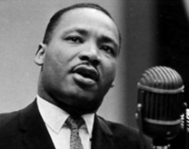
Rosa Parks and Martin Luther King Jr
In the 1950s there was a law in America that black and white people had to be segregated on the bus and that black people had to give up their seats for a white person. In 1955 a black lady named Rosa Parks refused to give up her seat for a white person. This led to the Montgomery Bus Boycott which was led by Martin Luther King Jr. Martin Luther King continued to fight for equal rights for black Americans, even after segregation rules were abolished. He did this using peaceful protests and powerful speeches which are still remembered to this day.

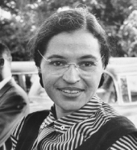

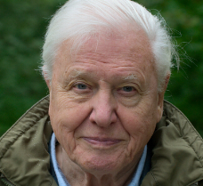
Sir David Attenborough
David Attenborough has travelled the world to make documentaries showing people how wonderful our planet is. He famously said ‘The future of humanity and indeed, all life on earth, depends on us’. David Attenborough celebrated his 100th birthday this year!

Greta Thunberg and Malala Yousafzai
Greta Thunberg is a Swedish environmental activist who challenges world leaders to take immediate action to help with climate change. She has travelled the world to make powerful speeches on the subject. Malala Yousafzai is a young Pakistani who was attacked by a group of people in her country. She spoke out for the education on young girls who, at the time, were not allowed to go to school. She is the youngest person to have received a Nobel Peace Prize.



