
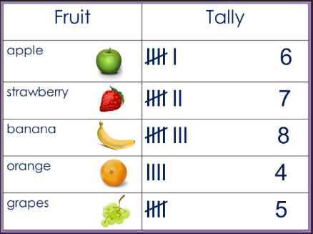

A tally chart is a simple way of recording data and counting the amount of something (known as the frequency).
Tally Chart
Geometry
Position and direction.
Statistics
Year 2 Firecrests
Mathematics
Summer 2

This half term, we will be learning about the Industrial Revolution.

Key Vocabulary |  | Definition
Position and direction | anti-clockwise | It turns/ moves around in the opposite direction to the way in which the hands of a clock move round
Position and direction | backwards | To move further away from the object that you are facing.
Position and direction | clockwise | Matching the way in which the hands of a clock move
Position and direction | forward | To move in the direction that something is facing or travelling towards the front. To move closer to something in front.
Position and direction | half-turn | A reversal of direction to face the opposite way by making 2 right angled turns.
Position and direction | position | A particular way in which something is placed or arranged
Position and direction | rotation | The action of moving around an axis or centre
Statistics | diagram | A simplified drawing showing the appearance or workings of something
Statistics | efficiently | A way to complete the most tasks without too much time
Statistics | pictograms | A pictorial graph where pictures represent numbers
Statistics | statistics | The practice of collecting and analysing numerical data.
Statistics | tables | A set of facts or figures displayed in columns
Statistics | tally chart | A simple way of recording and counting frequencies

They are used to collect data quickly and efficiently since filling a chart is quicker than writing words.

Pictograms

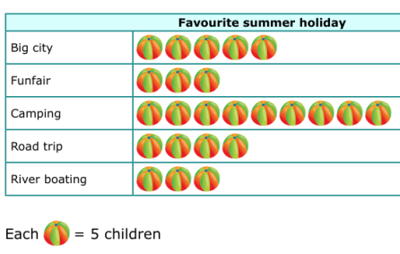
A pictogram is a pictorial representation of the data. A tally chart is created and then this chart is used to create a pictogram which can show how many people like certain things.

Statistics
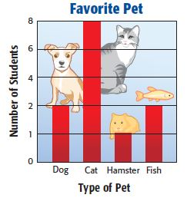

Statistical information can be presented in diagrams, graphs and charts. The type you use will largely depend on the sort of data that you want to present. These can include bar charts, pie charts, line graphs and tally charts.
Geometry:
Movement can be described in different ways.


