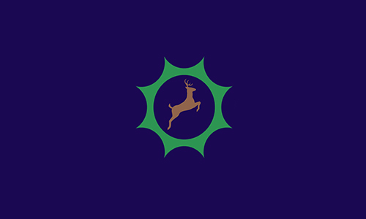
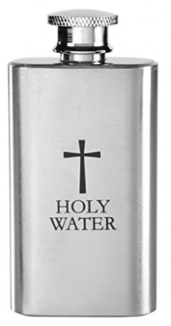
Water
Water can be seen as a symbol of cleanliness. Christians use water during baptisms; Muslims use water (Wudu) to wash before prayer; and there is a special spring in Mekkah (ZamZam Water) that is continually flowing.

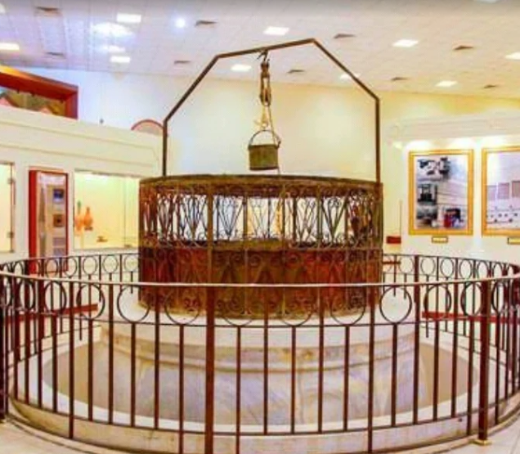
Symbols
and
Artefacts
Year 2 Firecrests
Religious Education
Summer 2

This half term, we will be learning about the Industrial Revolution.

Holy water
The ZamZam Well
Key Vocabulary | Definition
Christianity | The religion based on the life, teachings, death, and resurrection of Jesus Christ.
Islam | A religion based on the belief in one God (Allah) and the teachings of Prophet Muhammad.
Judaism | The religion, culture, and way of life focusing on the belief in one God and a covenant.
artefact | An object made or shaped by human beings that have cultural or historical significance.
bread | A common food eaten daily. A religious symbol for sharing something together.
celebration | a special event or festival.
community | a group of people who live, learn, work or belong together.
cross | One of the symbols for Christianity. Jesus died on the cross.
light | Something that helps us see. Brightness. It often represents goodness, guidance and hope.
Star of David | A symbol for Jewish people. It is a six-pointed star made up of two triangles.
symbol | A mark, sign, object, or character that represents, suggests, or stands for something else.
water | A transparent, odourless, tasteless, and nearly colourless liquid. A symbol for being clean.
worship | Showing love and respect to something or someone.

Bread
In Christianity, bread is seen as the body of Christ which is eaten during the Communion service. Jews eat challah, a type of bread, every Friday during Shabbat. It symbolises joy, rest and specialness of Shabbat.

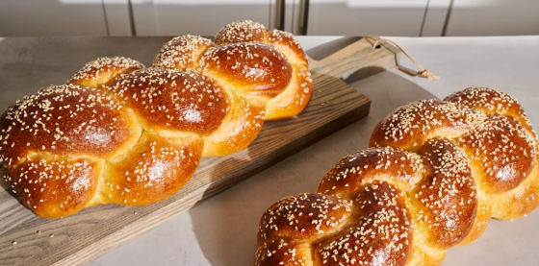
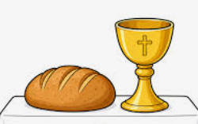

Holy Communion bread
Challah bread

Light
Christians have candles in churches to remind them that |Jesus was the light of the world. During Hannukah, Jews have candles in a menorah. One is lit every night to remember the miracle of light.

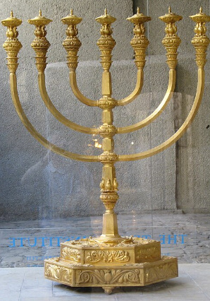
Traditional oil lamp
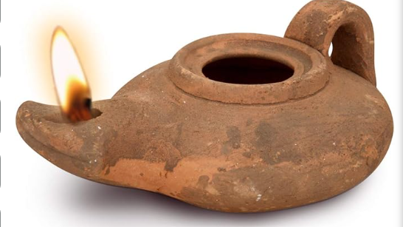
menorah

Religious Symbols
All religions have symbols that mean something to their followers. Christians have the cross, representing death and salvation of the world. The Star of David is part of the Jewish religion, and it signifies divine protection, the connection between God and humanity, and unity with one another. Muslims have a crescent moon and star. These represent divine guidance, new beginnings, and the balance between the soul's inner (star) and outer (crescent) experience.
Artefacts
An artefact is something from the past that can be touched or seen. Religious artefacts are important because they serve as real, physical links to the gods, acting as aids to faith, and focus points for devotion.


