Astronomy

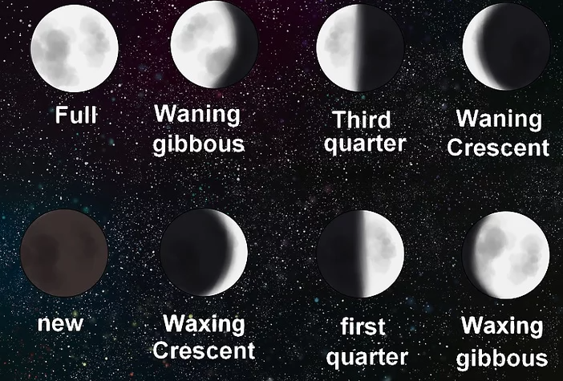
Phases of the Moon
It takes around a month for the Moon to pass through its phases, this is the word we use to describe the changing shape of what we can see. The Moon doesn’t shine its own light; it reflects the Sun’s light.

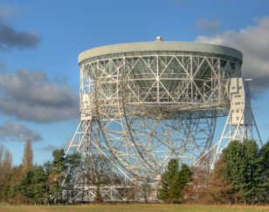
Year 2 Firecrests
Science
Summer 1

This half term, we will be learning about the Industrial Revolution.

Key Vocabulary | Definition
astronaut | A person who is trained to travel in a spacecraft.
constellation | A group of stars that form a pattern or picture that people have told stories about.
moon | The moon orbits the Earth. It is made of rock and metal. Some but not all planets have moons. Some planets have more than one moon.
moon phases | The changing shape of what we can see of The Moon during a month.
orbit | The path of an object around another. They usually follow a circular shape. The Earth orbits the sun.
planets | The planets in our solar system are: Mercury, Venus, Earth, Mars, Jupiter, Saturn, Uranus and Neptune.
reflect | When light bounces of an object.
robot | A machine that can perform tasks, much like a human can do.
rotate | Turning around on an axis. The Earth rotates as it orbits the sun.
Solar System | The Sun, the eight planets and their moons.
space exploration | The use of scientific knowledge, astronomy and technology to explore outer space.
The ISS | The International Space Station. Astronauts can live there for long periods of time.
waning | When we can see less of The Moon.
waxing | When we can see more of The Moon.

What is a constellation?
A constellation is a group of stars in the night sky that make up a recognisable picture or pattern. The shapes they might take include animals, objects, or people. Many of the human-shaped patterns have been named after mythological figures from the ancient world.

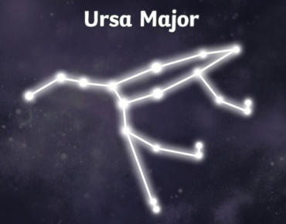

The International Space Station
The ISS was built in the 1980’s, by many scientists around the world working together, to allow astronauts to live in space. Tim Peake lived on the ISS in 2015, along with two other international astronauts. He was there for six months.

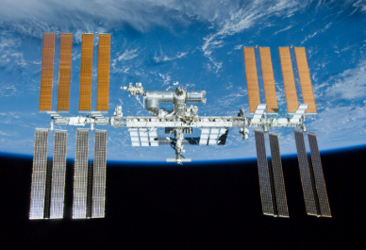

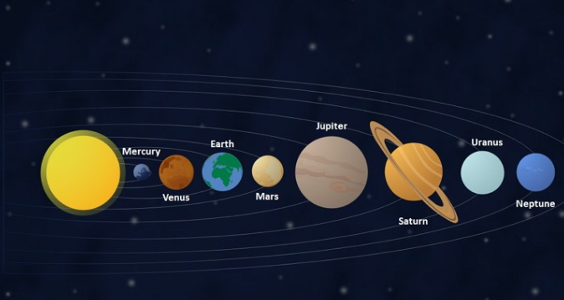
Space Travel
In 1969, humans first landed on the moon. Neil Armstrong was the first astronaut to walk on the moon.

Tim Peake is a British astronaut who has been into space.

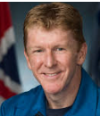
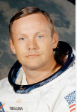
The Planets
The planets in our solar system are Mercury, Venus, Earth, Mars, Jupiter, Saturn, Uranus and Neptune. We live on Earth, sometimes called the Third Rock from the Sun.

