Glade Academy School Council Meeting

Date:  18-11-22  Time:  1:00pm | Present:  FR LG NM AD MiM EE MaM FJ Mrs J  Apologies:
Item
1 | Present and Absent – all members present
2 | Matters arising from last meeting  - KS2 Lego club – bring this up with classes in relation to Mrs Peck’s request below  - Design a Christmas jumper competition – we can do this if we have time to organise it  - Hot dogs/popcorn for dinner – school does not set the menu  - An Art Day – Mrs J will discuss with Mrs P  - Whole school movie – bring this up again in the Summer term
3 | Flowers and card for Mrs Whistler –  - A card was written by AD for Mrs Whistler to say thank you for playing during our Remembrance Ceremony. Mrs J is to buy some flowers out of School Council budget for her, too. Mrs J will ensure the flowers and card get to her.
4 | Plant donation from Brandon in Bloom  - A card was written for Brandon in Bloom by LG to say thank you for the donation of flowers. Mrs J will give the card to the office to forward.
5 | Hedgehogspital  - Mrs J talked about her visit to the Hedgehogspital over the half term break. Karen has said School Council are more than welcome to visit. Mrs J will liaise with Miss M to look into a suitable date for this (probably late in the Spring term)  - Mrs J explained about the donations box in the foyer and asked reps to let their classes know it is there ready for any donations of newspapers, Gu pots, dry cat or dog food and old towels.  - Mrs J is to ask for Dojo access to all classes so she can add information about the Hedgehogspital (as well as putting it on the school page)
6 | 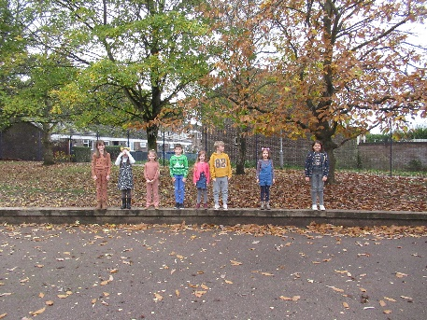  Buddy Bench  - School Council members went outside to decide on a suitable position for the seating area. It was thought that being two sleepers long would be enough, and the area on the righthand side of the playground was chosen. Mrs J will discuss with Miss M and Mr Preston.
7 | Peace and Quiet Area  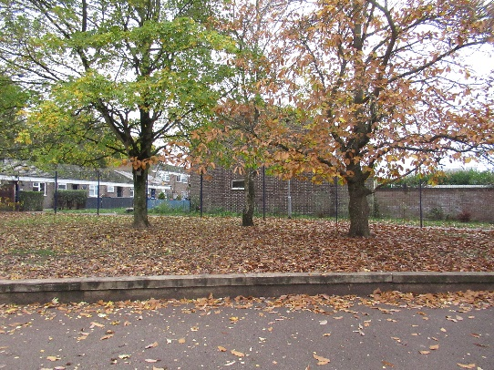  - As with the Buddy bench area, School Council members went outside to decide the suitable position. It was thought that the area directly behind the proposed Buddy Bench space would be good, in particular between these three trees. Some ideas discussed while outside were to wind something around the trees to make the space, and to move the logs from further up the field to this space.
8 | Lucky Dip Donations  - School Council have been donated some ready-wrapped gifts suitable for EYFS and KS1. Mrs J will liaise with Mrs P and CoGS to find out when this can take place.
9 - AOB | Herons
9 - AOB | Kestrels
9 - AOB | Skylarks | - Outdoor sound system to use – would have improved the Remembrance ceremony
9 - AOB | Blackbirds | - Friends day  - Christmas door competition  - Wear football kit for the day  - Team colours day  - Language day  - After school movie with popcorn etc
9 - AOB | Robins
9 - AOB | Swifts
9 - AOB | Swallows | - What clubs would children like to be offered
9 - AOB | Woodpeckers
Actions
School council reps to:
- Ask their class to list some clubs they would like to take place. Mrs Peck would like to know what clubs we would like to take part in. By our next meeting, please have a list of club suggestions from your class.
Mrs Jones to:
- Liaise with TM to discuss AOB items
- Discuss fundraising ideas with staff
- Talk to TM about visit to Hedgehogspital
- Talk to KP about Lucky Dip stall
- Talk to KP and CoGS about an outdoor sound system
- Give Brandon in Bloom card to the office
- Give Mrs Whistler her card and flowers
- Ask for Dojo access to classes not already on
- Liaise with RP regarding Buddy Bench
- Talk to staff regarding Peace and Quiet area
Next Meeting
FRIDAY 2nd December 2022 at 1:00pm

