Glade Academy School Council Meeting

Date:  10-3-23  Time:  1:00pm | Present:  FJ RB FR NM AD MiM MaM EE Mrs J  Apologies:
Item
1 | Present and Absent  - All present
2 | Matters arising from last meeting  - Mrs J took the photograph and will put it on the School Council board as soon as possible
3 | Eat Them to Defeat Them  - Competition prizes. Mrs J showed School Council some of the knitted vegetables that are prizes. There are more coming. Mrs J will put the photo on Dojo along with information about the competition again. 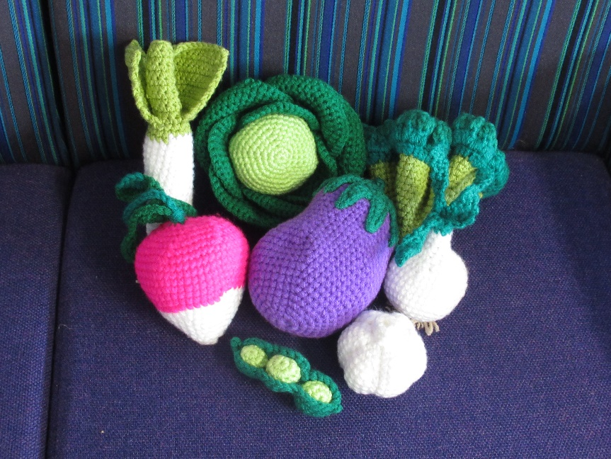
4 | Outdoor Active Play Equipment  - Herons – football goals  - Kestrels  - Skylarks - big maze with walls going out, knitting, more frizbees  - Blackbirds – football posts, big lego bricks, sharing wooden skis, blindfolds for guiding, mini basketball hoops  - Robins - bouncy balls, hula hoops, frogs, volleyball club (lunchtime club?) teddy area (outdoor classroom), tennis rackets, skipping ropes, slide?, space hoppers, building blocks (big ones?)  - Jays – slide, swing, rock wall, seasaw, climbing frame, monkey bars, pyramid spider climbing frame, zipline, roundabout, 4-way ball basket (like the old one), outdoor instruments  - Hummingbirds – goals for footballs, footballs and basketballs, more hoops, more space hoppers, wooden blocks, more bats and balls, puppets and a place to do shows, snakes and ladders, role play area, first aid area, outdoor bowling game, more chalk, playhouse  - Owls
5 | Badge machine  - Mrs J has the use of a badge machine. The badges will be 55mm wide. There will be a stack of circles in each classroom which children can take home to decorate etc. They will need to return each circle they want made into a badge in a sealed envelope with £1 for each badge (if someone wants to make three badges they will take three circles, decorate and return in an envelope with £3) Mrs J will put information on Dojo. School Council agreed that Mrs J should buy a bag of 200 components. We can always order more if needed.
6 - AOB | Herons | - Ideas to improve outside – role play area, gaming area, sleep area, sand pit, mud pit,  - Being able to kick small balls on the playground  - Lunch staff are putting chairs away before everyone has had their food
6 - AOB | Kestrels
6 - AOB | Skylarks
6 - AOB | Blackbirds
6 - AOB | Robins | - More clubs (lunchtime clubs, after school clubs (cricket, building club, gardening club, )  - Eating lunches outside?  - Calming area at lunchtime?  - Tennis at lunchtime?  - Insect club (learn about and observe insects)  - Friendship bench (we know this has been raised before, but don’t remember)  - Play leaders?  - Dancing area?  - Vending machines prizes- do something good at school you can take a prize from the vending machine.
6 - AOB | Jays
6 - AOB | Hummingbirds
6 - AOB | Owls | - Badge logo ideas – a unicorn, fox, rabbit, birds, cat, tree, acorn, leaves
Actions
School Council reps to:
- Hold a meeting before the next School Council meeting
Mrs Jones to:
- Liaise with Miss M regarding AOB items
Next Meeting
Friday 24th March at 1pm.

