G L A D E N E W S L E T T E R
(26th March 2021)
Dear Parents, Carers, Children and Community,

This term has certainly been one like no other!

Remote learning has definitely provided its challenges over the last term, so firstly we would just like to say a massive THANK YOU.


- Thank you to our children for showing great determination and resilience, trying their best even when things felt challenging.
- Thank you to our parents for supporting their children even when it seemed an impossible challenge; we have noticed how much the children have remembered from their time learning at home!
- Thank you to our volunteers who came and helped wherever they could, whether it was delivering remote learning packs or helping ensure food parcels were able to be delivered, your time was greatly appreciated.
- Finally, a huge thank you to all our staff who completely changed their craft in a matter of hours to create some fantastic remote learning videos (watch out Blue Peter here we come!)

As a community, Team Glade, has sought to ensure that throughout this time, we were together; thank you for the comments from parents, carers and friends which have really reflected that we truly have been in it together, learning and growing in what was unchartered territory for all of us.

We have had lots planned in this short term! World Book Day was a great event which brought so many of us together to discuss one thing we absolutely love at Glade: Reading! We loved seeing all the costumes from everybody and I even think we saw some of those lost crayons in the Year Five bubble!

Obviously, World Book Day also saw a brilliantly fun activity in the Masked Reader. Thank you to Mrs Potschul for organising the event and all the teachers who were such great sports in making their ‘secret’ recording. I bet not many guessed Mrs Gaught’s attempt correctly.

Since being back at school, we have completed Emotional Wellbeing think sheets regularly; a science week create-an-insect competition; ‘A Wish for the World’ PSHE project; participated in Tesco’s ‘Why I Wear a Mask’ competition; and completed two Easter craft activities. All alongside our whole school Oliver Jeffers novel in English: ‘What We’ll Build.’

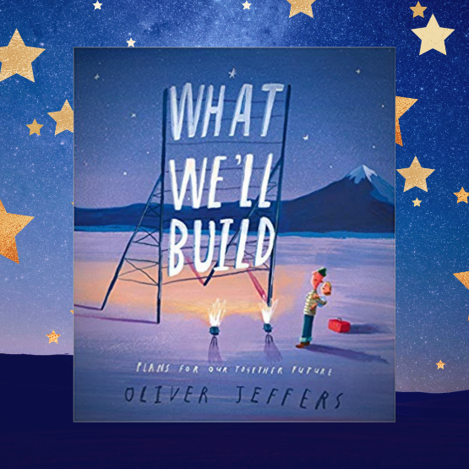

Despite all of those lovely activities, the best thing though has definitely been able to watch the children back in school working and playing with their friends. We know that it is one of the things that they have all missed so much whilst working from home.

Finally, we would like to make you aware that we have now ‘gone live’ with our Brand New Website. Please feel free to check it out and here you will find some further details about some of our competitions
Mr McDonald :)

A Wish for the World
As we welcomed all the children back into school, we wanted to support the children of Glade to look forward to the future and to create an atmosphere of positivity.
In our PSHE Wish for the World project, we asked the children to think about the things that are really important to them and to humanity. We talked about the Glade core values of respect, resilience and teamwork and thought about the things that really help to make our lives happy and healthy – love, compassion, equality, healthcare, food, shelter and the environment to name just a few.
We asked the children - “If you could make one wish for the world what would it be?” What did your child wish for?
The children came up with some fantastic ideas and wrote their wishes onto fabric strips. We have created an outdoor ‘Wish for the World’ display. This can be seen near the side entrance to the school.
We hope you like it.
Mrs Wilderspin
PSHE lead

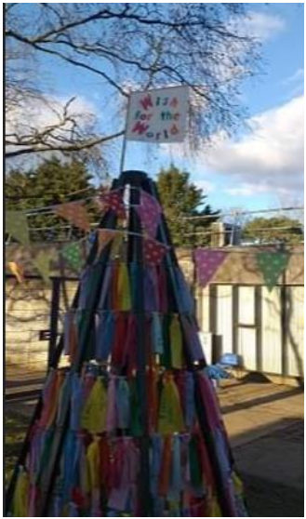
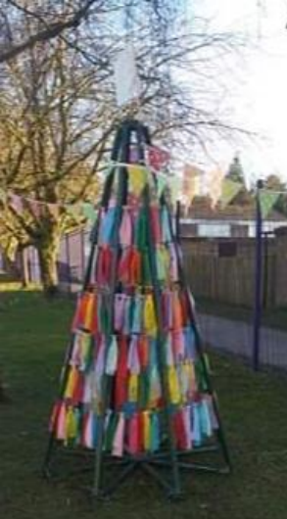

Science Week

As part of the STEMPOINT challenge for Science Week (5th March-14th March), children across the school were tasked with creating their own insect using four sheets of paper.
Easy I hear you say! However, our budding engineers had to craft the insect simply with four sheets of paper and nothing else! No glue; No cellotape; No pins or clips, only four sheets of paper and their ingenuity.
Techniques used included origami, twisting paper together or creating a slot design to interlock their designs.
This proved no mean task…however, by living our school’s core values of resilience and teamwork, the children were able to create a number of many wondrous insects from ladybirds to aphids, from butterflies to caterpillars.
The winning design for the school was made by Ted and Jack (Kestrels). I’m sure you will agree they have thought very carefully about how to create an insect!
Mr McDonald
Science Lead
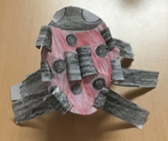

Masked Reader (World Book Day)
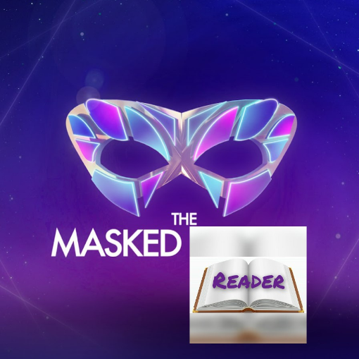

Thank you to everyone that took part in our Masked Singer competition on World Book Day. I hope you enjoyed watching the videos and guessing who was behind the mask as much as we did!

The winners for each class are:

Snowy Owls – Louis
Tawny Owls – Jasmine
Woodpeckers – Ben
Swifts – Penelope
Swallows – Joshua and Martha
Robins – Mollie
Blackbirds – Jacob
Skylarks – Oscar
Kingfishers – Olivia B
Herons – James
Kestrels – Ted
Thank you and well done to everybody who took part! Please find photographs on our website.

Mrs. Potschul
Masked Reader Organiser

Have you been to Tesco?

Have you been to Tesco? If you have, did you manage to spot the competition winners from Glade Academy for the “Please wear a mask…” competition.

It was very special to share with the children all of their hopes and dreams for the future when things can be a little more ‘normal.’

There were two winners per class and Tesco kindly donated an Easter Egg to each person who won.

The winners are

Woodpeckers – Max and Lana
Swifts – Sapphire and Emilia
Swallows – Joshua and Robbie
Robins – Luke S and Bella
Blackbirds – Danielius and Finlay J
Skylarks – Wiktoria and Florence
Kingfishers – Olivia C and Kenzie
Herons – Sam MB and Emily
Kestrels – Seb and Nina

Also, please check our Website or Class Dojo app to find out the winners of our brilliant Cel-EGG-rity and Easter Bonnet competitions.

Charity Fundraising Efforts

We know that many of our children personify the school’s core values of respect, resilience and teamwork.

Nowhere is this more obvious than the selfless acts of determination to raise money for charity and to help those less fortunate than themselves.

Firstly, a huge CONGRATULATIONS to Mollie Harvey who raised a whopping £469.63 for the NHS Charities by giving up chocolate.
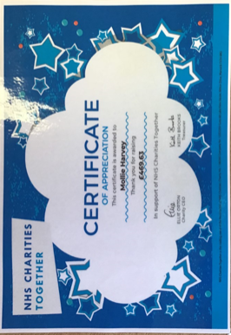

Another superstar fundraiser is Penelope in Swifts who is growing her hair to have it cut for The Little Princess Trust and raise money on just giving for Leukaemia Care, which at the time of writing stood at nearly £500!


Have a happy Easter!
From TEAM GLADE

